Software Requirements Specification
for
<Songify>
Version 1.0 approved
Prepared by:
Faizan Shabir 22L-6552 6H
Ahmed Mukhtar 22L-8225 6H
Tahawar Ali 22L-6761 6H

<FAST-NUCES>
< 13-03-2025>

Table of Contents
Table of Contents 1
Revision History 1
1. Introduction 2
1.1 Purpose 2
1.2 Document Conventions 2
1.3 Intended Audience and Reading Suggestions 2
1.4 Product Scope 2
1.5 References 2
2. Overall Description 2
2.1 Product Perspective 2
2.2 Product Functions Error! Bookmark not defined.
2.3 User Classes and Characteristics 5
2.4 Operating Environment 5
2.5 Design and Implementation Constraints 5
2.6 User Documentation 6
2.7 Assumptions and Dependencies 6
3. External Interface Requirements 6
3.1 User Interfaces 6
3.2 Hardware Interfaces 6
3.3 Software Interfaces 6
3.4 Communications Interfaces 6
4. System Features 6
4.1 Basic Music Player Features 7
4.2 Download Music 7
4.3 Manage Music Libraray by Artist or Genre ………………………………………………...7
4.4 Theme Selection …………………………………………………………………………….8
4.5 Notifications and Widgets …………………………………………………………………. 8
4.6 Optional AI Integration (Strech Goal) ………………………………………………………9
5. Other Nonfunctional Requirements 9
5.1 Performance Requirements 9
5.2 Safety Requirements 9
5.3 Security Requirements 9
5.4 Software Quality Attributes 9
5.5 Business Rules 10
6. Other Requirements 10
Appendix A: Glossary 10
Appendix B: Analysis Models 10
Appendix C: To Be Determined List 10

Revision History
Name | Date | Reason For Changes | Version
Requirements Document | 13-03-2025 | New Document | 1.0

1. Introduction

1.1 Purpose
The purpose of this document is to define the software requirements for SONGIFY. The system will provide essential music playback features along with additional functionalities such as library management, offline playback, and optional AI-based recommendations.

1.2 Document Conventions
This Document was created based on the IEEE template for System Requirement Specification Documents. This document's content is written in Arial font with a size of 11. The body's major titles are written in Times New Roman, font size 18, while the subtitles are written in Times New Roman, font size 14. This document consists of text and different diagrams to elaborate the requirements. Requirements will be uniquely numbered (e.g., REQ-1, REQ-2).

1.3 Intended Audience and Reading Suggestions
This document is intended for software developers, project managers, UI/UX designers, and testers involved in the development of the application.

1.4 Product Scope
SONGIFY will enable users to play, manage, and organize music efficiently. It includes support for offline playback, customizable UI, and optional AI integration for personalized recommendations.

1.5 References
- IEEE SRS Standard

2. Overall Description

2.1 Product Perspective
The application will be a standalone Android mobile app, leveraging Android's MediaPlayer or ExoPlayer for audio playback.

2.2 Product Functions
- Basic Music Playback (play, pause, seek, shuffle, repeat)
- Library Management (browse music by albums, artists, genres)
- Offline Playback (play downloaded music)
- User Interface (intuitive design, dark/light themes)
- Notifications & Widgets (control music from notifications)
- Optional AI-based recommendations
Context Level Dataflow Diagram
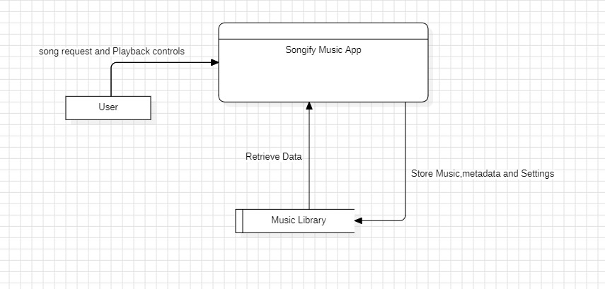
Level 1 Dataflow Diagram

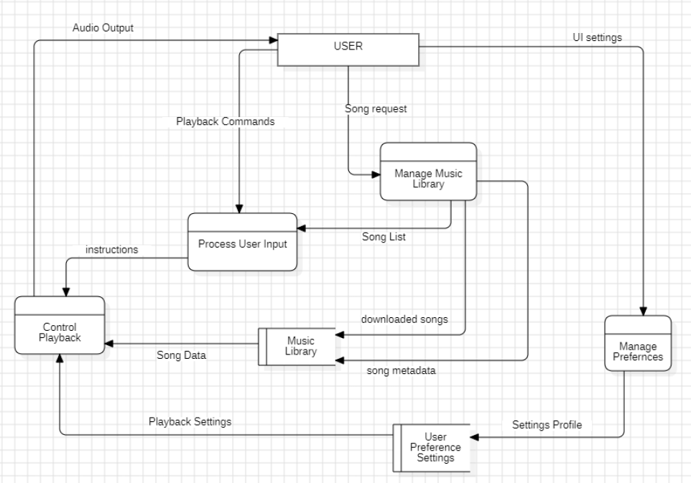

Use Case Diagram

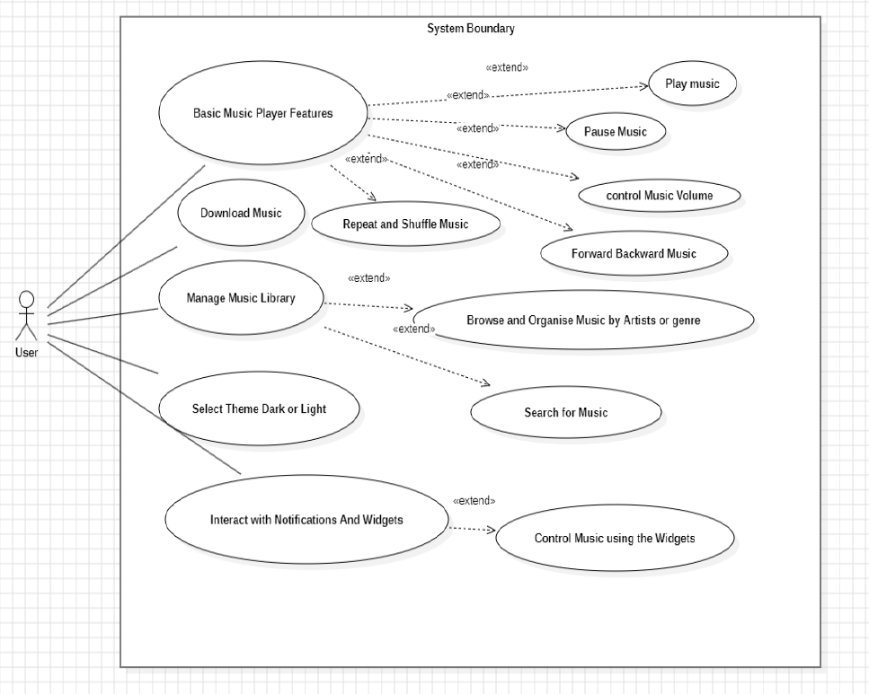

Abstract Class Diagram

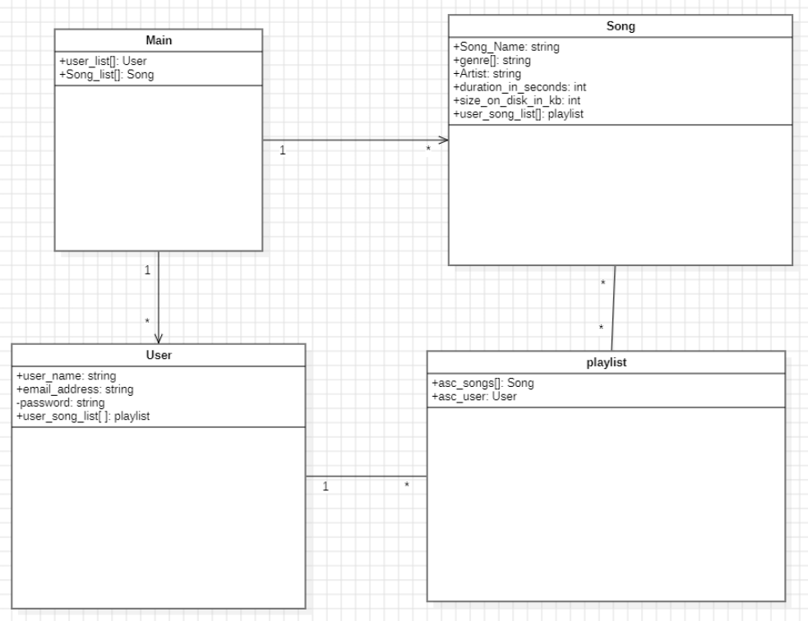

2.3 User Classes and Characteristics
- General Music Listeners: Users looking for a simple, efficient music player.
- Power Users: Users who organize music by metadata and require advanced playlist features.

2.4 Operating Environment
- OS: Android (API level 21+)
- Programming Language: Kotlin
- Backend (for AI Features): TensorFlow Lite (optional)

2.5 Design and Implementation Constraints
- Must follow Android UI/UX guidelines.
- Performance-optimized for low-end devices.

2.6 User Documentation
- Intuitive design of the application requires no user documentation such as a user manual

2.7 Assumptions and Dependencies
- AI-based features require internet connectivity.

3. External Interface Requirements

3.1 User Interfaces
- Material Design UI with dark and light themes.

3.2 Hardware Interfaces
- Supports headphone controls.

3.3 Software Interfaces
- Integrates with Android MediaPlayer or ExoPlayer.

3.4 Communications Interfaces
- AI-based recommendations require API access (if implemented).

4. System Features

4.1 Basic Music Player Features

4.1.1 Description and Priority
This feature provides essential playback controls, including play, pause, forward, and backward navigation. Users can adjust volume, use a seek bar for track navigation, and enable shuffle or repeat modes. Priority: High

4.1.2 Stimulus/Response Sequences
- User presses play → System starts playing the selected track.
- User presses pause → System pauses playback at the current position.
- User skips forward/backward → System moves to the next/previous track.
- User adjusts volume → System increases/decreases audio output.
- User seeks within a track → System plays from the selected position.
- User enables shuffle mode → System plays songs in random order.
- User enables repeat mode → System repeats the current track or playlist.

4.1.3 Functional Requirements
- REQ-1: The system shall allow users to play, pause, skip forward, and skip backward on music tracks.
- REQ-2: The system shall provide a seek bar for track navigation.
- REQ-3: The system shall allow users to control volume.
- REQ-4: The system shall provide shuffle and repeat playback options.

4.2 Download Music

4.2.1 Description and Priority
Users can download music for offline playback, enabling them to listen without an internet connection. Priority: Medium

4.2.2 Stimulus/Response Sequences
- User selects a song to download → System starts downloading the song.
- User plays a downloaded song → System plays the song without requiring internet access.
- User deletes a downloaded song → System removes the song from local storage.

4.2.3 Functional Requirements
- REQ-5: The system shall allow users to download music for offline playback.
- REQ-6: The system shall allow users to play downloaded songs without an internet connection.
- REQ-7: The system shall provide an option to delete downloaded songs.

4.3 Manage Music Library by Artist or Genre

4.3.1 Description and Priority
Users can organize and browse their music library based on artists and genres. Priority: Low

4.3.2 Stimulus/Response Sequences
- User selects an artist/genre → System displays all songs under the selected category.
- User searches for a specific artist or genre → System filters and displays matching results.
- User selects a song from the filtered list → System plays the selected song.

4.3.3 Functional Requirements
- REQ-8: The system shall allow users to browse music by artist and genre.
- REQ-9: The system shall provide a search function to filter songs by artist or genre.
- REQ-10: The system shall allow users to play songs directly from search results.

4.4 Theme Selection (Dark or Light)

4.4.1 Description and Priority
Users can choose between dark and light themes to customize the app’s appearance. Priority: Low

4.4.2 Stimulus/Response Sequences
- User selects dark mode → System applies a dark theme.
- User selects light mode → System applies a light theme.
- User reopens the app → System retains the last selected theme.

4.4.3 Functional Requirements
- REQ-11: The system shall provide an option to switch between dark and light themes.
- REQ-12: The system shall remember the selected theme across app sessions.

4.5 Notifications and Widgets (Control Music through Notification Bar in Background)

4.5.1 Description and Priority
This feature allows users to control music playback from the notification bar and a home screen widget. Priority: Low

4.5.2 Stimulus/Response Sequences
- User starts playing a song → System displays a notification with playback controls.
- User interacts with notification controls → System performs play, pause, next, or previous actions.
- User adds a home screen widget → System provides quick access to playback controls.

4.5.3 Functional Requirements
- REQ-13: The system shall display a notification with playback controls when music is playing.
- REQ-14: The system shall allow users to control playback from the notification bar.
- REQ-15: The system shall provide a home screen widget for playback control.

4.6 Optional AI Integration (Stretch Goal)
4.6.1 Description and Priority
Suggest songs based on user listening history and preferences.
Priority: Low
    - Stimulus/Response Sequences
TBD (to be decided)
    - Functional Requirements

- REQ-7: If implemented, the system shall analyze user preferences for recommendations.

5. Other Nonfunctional Requirements

Performance Requirements
5.1.1 The system shall run smoothly without any lag i.e. the screen shall not get stuck while user uses the system.

Safety Requirements
5.2.1 The system shall not interfere with other system audio functions provided by android that run in parallel with the music application.

Security Requirements
5.3.1 The system shall ensure that user data is not shared with third parties.

Software Quality Attributes
5.4.1 The system shall have an intuitive and responsive design.
5.4.2 The system shall have a modular architecture for future updates.

Business Rules
- TBD (to be decided)

6. Other Requirements
- None

Appendix A: Glossary
- Android ExoPlayer: An Android media player library provided by Google
- Android Media Player: Android media player library built-in to android
- TensorFlow Lite: A machine learning framework for mobile AI

Appendix B: Analysis Models
- Context Level Dataflow Diagram
- Level 1 Dataflow Diagram
- Use Case Diagram
- Abstract Class Diagram

Appendix C: To Be Determined List
- AI model implementation feasibility
- UI / Front End design
- Application operates locally or is online

